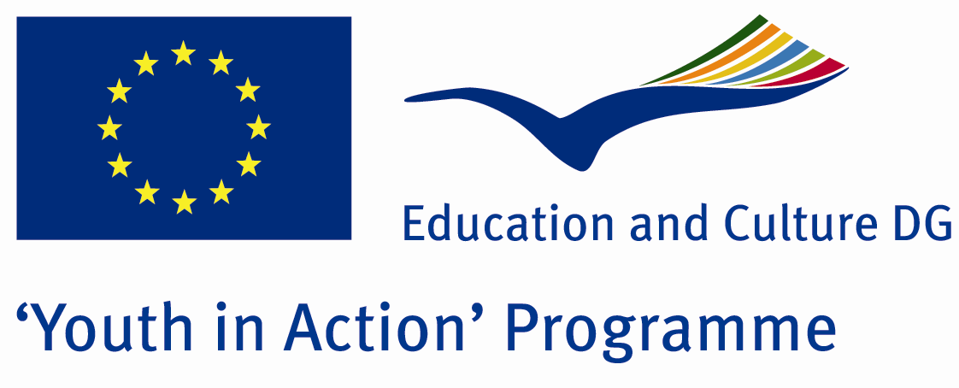

Adam And Eva



ACTION 1.1 – Youth Exchange

01-08th July, 2011

Izmit, TURKEY

ACTION 1.1 Youth Exchange
01-08th July, 2011
Izmit, TURKEY

Please contact directly to;
adventurerpeacepigeons@gmail.com

Project Summary; Have you ever thought that how many women are president or scientist in the world…Or even in the most democratic countries, how many women are there in parliament? Why do we try to behave a girl anda boy differently …What do we feel when we see a boy who is nurse or teacher of kindergarten or babysitter….What do we feel when we see a girl who is truck driver, repairwomen, or footballer…?? How many women have been died because of violence..?

In this Project, we try to take attention….Where do we live this? Especially , what kind of problems do women have?How do they prevent this?

Firstly, we give a short seminar about this subject and after that we try to learn everybody’s experiences with some art workshops…The workshops will be some kind of art like music, dance, theatre,hand art or the other…W e decide this later…These are only our some opinions..They can be changable..For this, of course we need some partners and participants..If you think to take place in this Project, please contact with us.

Project Title; Adam And Eva

Date and Venue ; 01-08th July, 2011 Izmit, Turkey .

Target Group ; Municipalities, City Councils and Non-Governmental organizations,
youth groups,culture and art groups,e.t.c

Participants ; 5 people from each country (over 18 -25 ). Totally 8 countries.

Conditions ; Accommodation, board and programme costs will be financed through European Commission Youth in Action Programme (Action 1.1). Travel costs will be reimbursed in 70% (APEX Tarrifs). Organizations from all 27 EU member countries plus Liechtenstein , Norway and Iceland are eligible to take part.

Working language: English

Organizer; Discovery And Adventure Group

How to apply: If you are interested, please send your Part III forms to
0090 216 483 21 67 by FAX please. (Fulfilled Part III which you can find in the attachment, of course signed and stamped) ..

Note: jpeg is not allowed..please send by fax…

Next step 2;
Original send via regular post to this address please:

Ertan DERİN
Öner İnşaat
Abdulhalik Renda Cd.
Parlar Sk. No:4 Pendik/İSTANBUL

If you have any questions you may contact with: adventurerpeacepigeons@gmail.com

Deadline for application; until 20th January 2011.

For Further information:
Contact Person
Ertan DERİN
Öner İnşaat
Abdulhalik Renda Cd.
Parlar Sk. No:4 Pendik/İSTANBUL

e-mail : adventurerpeacepigeons@gmail.com
Mobile : 0090 542 393 93 90
Fax : 0090 216 483 21 67

